# Voltage Lick Detector Rational

We have found that voltage lick detectors have been more consistent across systems at detecting licks for hypertonic NaCl. In general, for all users who will conduct experiments with solutions other than NaCl (e.g. sucrose, quinine, ensure, etc.), we recommend using the capacitive touch sensor for lick detection as outlined in the protocol_assembly.docx document. We advise against using the voltage lick detector unless necessary because voltage lick detectors require additional assembly and involve a greater number of steps and variables during operation. However, if set up properly, the lick detection with the voltage and capacitive detectors should be nearly identical.

# Voltage Lick Detector Overview

## Figure 1: Completed Detector

# Instructions - Voltage Lick Detector Module

## Components

### Purchased Components

|  |  |
| --- | --- |
| Item | Count |
| Breadboard (400 point, solderless) | 1 |
| 22 AWG solid core wire and/or MM jumper wire |  |
| DC power cable female connector | 1 |
| Custom jumper housing 1x4 | 1 |
| Custom jumper housing 1x5 | 1 |
| Custom jumper wire FM | 3 |
| Custom jumper wire F_ | 5 |
| Resistor 47 Ω | 1 |
| Resistor 10 kΩ | 1 |
| Resistor 10 MΩ | 1 |
| Transistor 2N2222A | 2 |
| Reed Relay (EDR2D1A0500) | 1 |
| Inverter Schmitt Trigger (CD40106BE) | 1 |
| F pigtail power adapter plug | 1 |
| 9V 1A power adapter | 1 |
| Alligator clip wire | 1 |
| Foil or sheet metal | ~8x4cm |

### 3d Printed Components

|  |  |
| --- | --- |
| Item | Count |
| voltage_lick_detector_enclosure_bottom.stl | 1 |
| voltage_lick_detector_enclosure_top.stl | 1 |

### Tools / consumables

|  |
| --- |
| Item |
| Soldering iron |
| Solder |

## Figure 2: Enclosure

voltage_lick_detector_enclosure_bottom.stl

voltage_lick_detector_enclosure_top.stl

## Figure 3: Circuit

## Assembly guide

1. Print out the Voltage Lick Detector enclosure top and bottom (**Fig. 2**).
2. Assemble the circuit as shown in **Fig. 3** using the components listed in the Components section.
3. Use JB weld epoxy to fix the custom jumper housing (2 1x1 on Front Pannel, 1 1x4 on Back Pannel) along with the F pigtail power connector (Back Pannel).

# Instructions – Common Spout

## Figure 4: Completed Common Spout

## Assembly guide

1. Make a 1x5 F custom jumper ribbon cable.
2. Cut and strip jumper wires to expose ~2cm of wire.
3. Twist all wires together to form a single wire and embed with solder.
4. Solder combined wire to a 1x1 MM jumper wire.
5. Use heat shrink to cover the joint between the two wires.

# Instructions – Conductive Mouse Cradle and Wire

## Figure 5: Examples of conductive mouse cradles

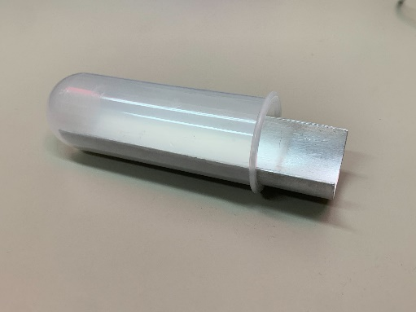 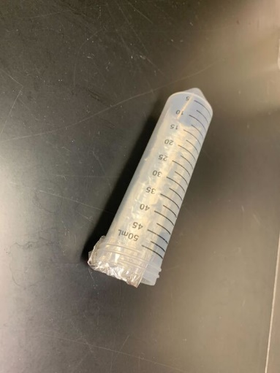

## Assembly guide - Cradle

Option 1: Foil

1. Fold a piece of foil several times to make a rectangle ~8x4cm.
2. Press foil into a plastic tube until it conforms to the shape of the tube.
3. Foil can be secured to the tube using an alligator clip during operation.

Option 2: Sheet metal

1. Obtain a piece of sheet metal ~8x4x0.2cm.
2. Bend the sheet metal to match the internal dimensions of a plastic tube.

## Assembly guide – Wire + Clip

1. Solder or clip an alligator clip wire to a MM jumper wire.

# Setting up Voltage Detector

## Connecting to the Arduino Console

The voltage lick detector circuit was designed to match the wire configuration used for the cap sensor. A 1x4 ribbon connector can be used to connect the “Lick” 1x4 on the Arduino Console to the Back Pannel on the Voltage Lick Detector. Ensure that the ground pin is to the right side of the 1x4 ribbon cable when looking at the enclosure face (see Back Pannel above and Box External Connectivity Key below). The first pin from the left should be connected to Arduino pin #20, which is typically used for the cap sensor. This pin is not necessary for the Voltage Lick Detector and will be housed in an empty position within the 1x4 connector in the Back Pannel.

**Figure 6: Arduino Console Connectivity Key**

## Connecting to the Common Spout

Connect the M pin of the Common Spout to the “Spout” position of the Front Pannel. If necessary, attach an extension MF jumper wire to allow the Common Spout to reach the Front Pannel.

## Connecting to the Conductive Mouse Cradle

**Figure 7: Connected Cradle**

Connect the M jumper wire attached to the alligator clip wire to the “Mouse” position of the Front Pannel. Check to ensure that the free alligator clip is able to reach the position of the plastic tube.

# Daily Operation

1. Setup OHRBETS behavioral program, ensuring that the lick_detection option is set to 1.
2. Insert Conductive Mouse Cradle into the tube prior to scruffing the mouse and placing them in the tube.
3. Head-fix the animal as normal.
4. Clip the free alligator clip to the Conductive Mouse Cradle.
5. Conduct behavior as normal.

# Trouble shooting / important notes.

Notes:

* If the voltage from the power adapter is accidentally reversed (+ connected to -), the chips will be irreversibly damaged. If you noticed that this has occurred, you may need to swap out both chips.

Problem: No lick detection

Explanations and Potential Solutions:

* **The Arduino program is not configured properly.** Check to ensure that the Arduino program being used to measure licks is configured for using the voltage sensor.
* **Open circuit from the alligator clip and the spout.** Use a multi-meter to test the circuit from the alligator clip to the spout. If the circuit is not complete, check each component of the circuit with the multi-meter to ensure that everything is correctly connected. Also check to ensure that the spout to common spout is properly connected.
* **Broken Smit Trigger and/or Reed Relay.** Listen for the sound of the Smit Trigger when the alligator clip touches the spout for a faint “tink” sound. If you cannot hear any sound, then it is possible that the circuit is not setup properly or one of the chips is malfunctioning. After confirming the circuit is setup correctly, try swapping out each chip.

Problem: Inconsistent lick detection

Explanations and Potential Solutions:

* **Poor contact between the alligator clip and the Conductive Mouse Cradle**. Thoroughly clean the point of contact prior to use. If using a sheet metal cradle, periodically use sandpaper to rough up the surface at the point of contact.

Problem: Erroneous lick detection

Explanations and Potential Solutions:

* **Noise from solenoid is being picked up by the voltage lick detector**. Sheild the solenoids and ensure they are located on the exterior of a metal compartment relative to the voltage sensor. Increase the minimum lick time to up to 80ms (this will miss a very small fraction of licks).